## Step-03: Create Frontend Deployment & LoadBalancer Service

## Front end deployment yaml

## 

## 

## Front end load balancer yaml

## 

* Write the Deployment template for frontend Nginx Application
* Write the LoadBalancer service template for frontend Nginx Application

cd 04-05-Services-with-YAML/kube-manifests

kubectl get all

kubectl apply -f 03-frontend-deployment.yml -f 04-frontend-LoadBalancer-service.yml

kubectl get all

* **Access REST Application**

# Get Service IP

kubectl get svc

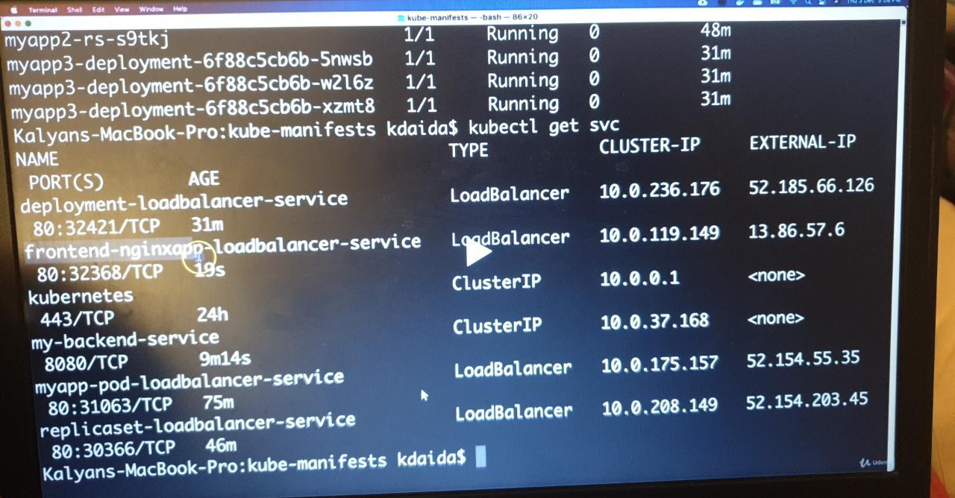

# Access REST Application

http://<Load-Balancer-Service-IP>/hello

rest applications we need to access through via external IP

## Delete & Recreate Objects using kubectl apply

### Delete Objects (file by file)

kubectl delete -f 01-backend-deployment.yml -f 02-backend-clusterip-service.yml -f 03-frontend-deployment.yml -f 04-frontend-LoadBalancer-service.yml

kubectl get all

### Recreate Objects using YAML files in a folder

cd 04-05-Services-with-YAML/

kubectl apply -f kube-manifests/

kubectl get all

### Delete Objects using YAML files in folder

cd 04-05-Services-with-YAML/

kubectl delete -f kube-manifests/

kubectl get all

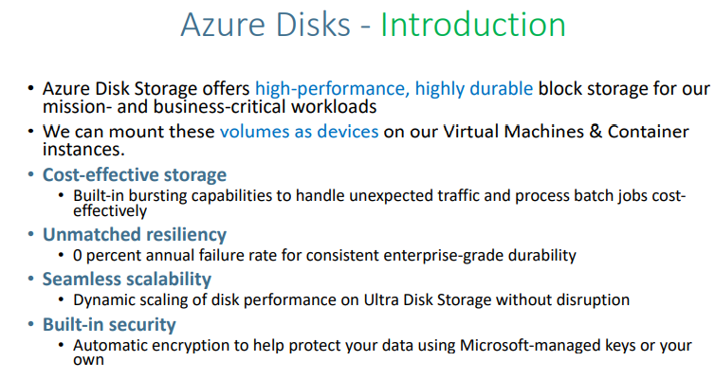

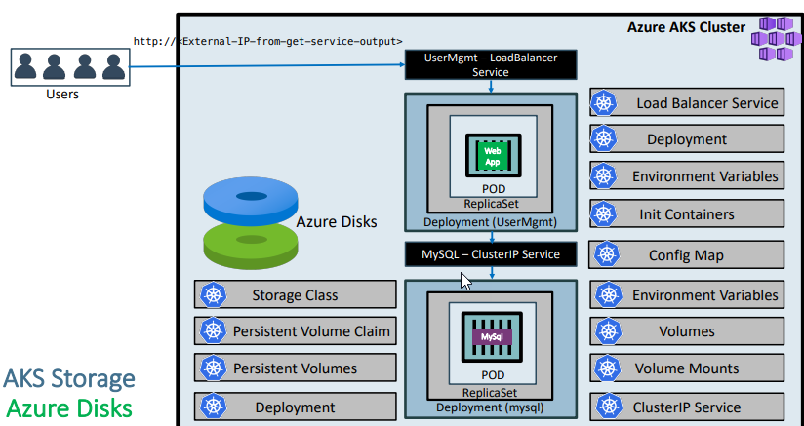

**Concepts**

| **Kubernetes Object** | **YAML File** |
| --- | --- |
| Storage Class | 01-storage-class.yml |
| Persistent Volume Claim | 02-persistent-volume-claim.yml |
| Config Map | 03-UserManagement-ConfigMap.yml |
| Deployment | 04-mysql-deployment.yml |
| Environment Variables | 04-mysql-deployment.yml |
| Volumes | 04-mysql-deployment.yml |
| VolumeMounts | 04-mysql-deployment.yml |
| ClusterIP Service | 05-mysql-clusterip-service.yml |
| Deployment | 06-UserMgmtWebApp-Deployment.yml |
| Environment Variables | 06-UserMgmtWebApp-Deployment.yml |
| Init Containers | 06-UserMgmtWebApp-Deployment.yml |
| Load Balancer Service | 07-UserMgmtWebApp-Service.yml |

Kubectl get sc(it is for storage class)

AKS Storage - Storage Classes, Persistent Volume Claims

Step-01: Introduction

We are going to create a MySQL Database with persistence storage using Azure Disks

Kubernetes Object YAML File

Storage Class 01-storage-class.yml

Persistent Volume Claim 02-persistent-volume-claim.yml

Config Map 03-UserManagement-ConfigMap.yml

Deployment, Environment Variables, Volumes, VolumeMounts 04-mysql-deployment.yml

ClusterIP Service 05-mysql-clusterip-service.yml

Storage Class 01-storage-class.yml

Create Storage class  
Kubernetes Manifest

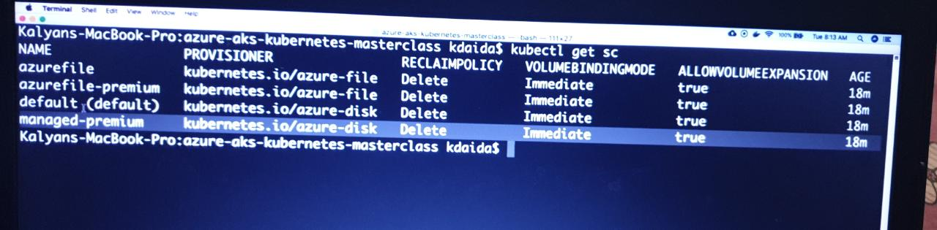

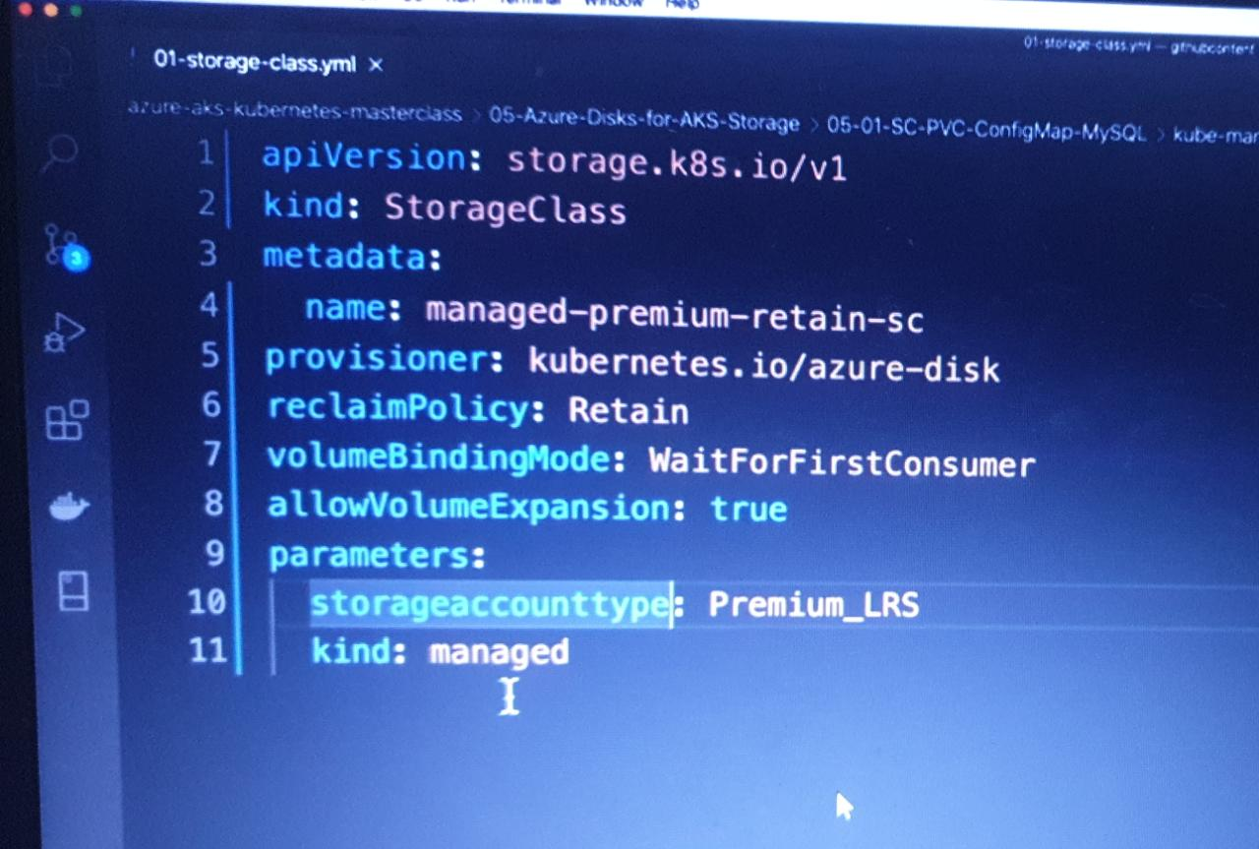

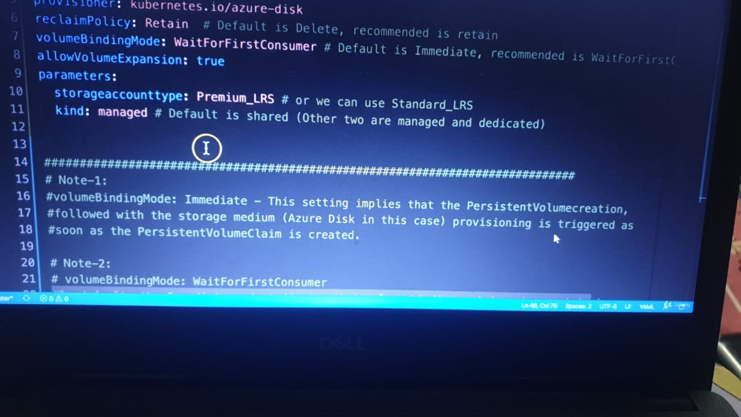

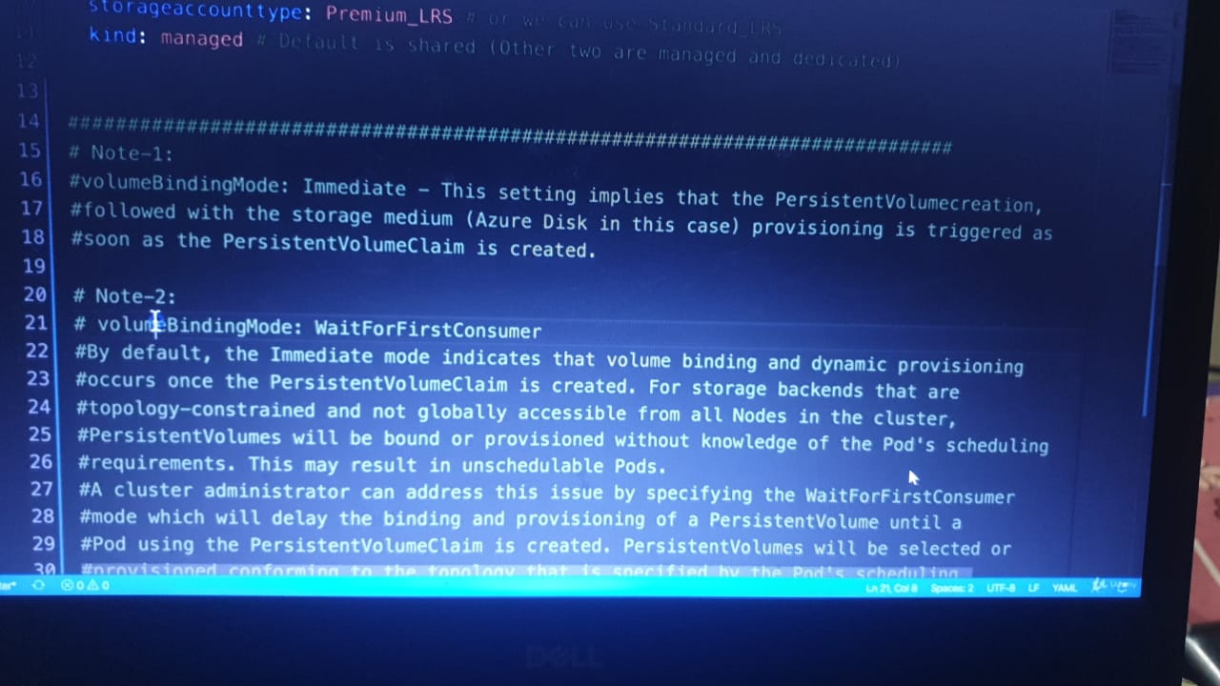 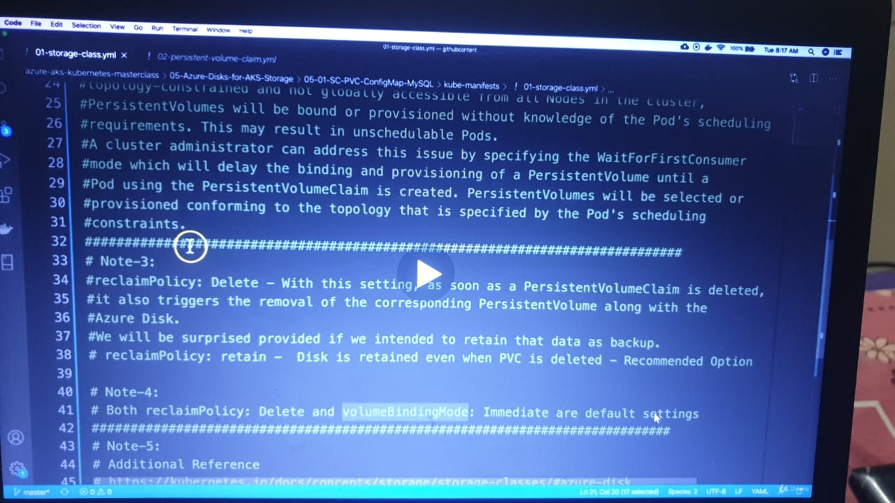

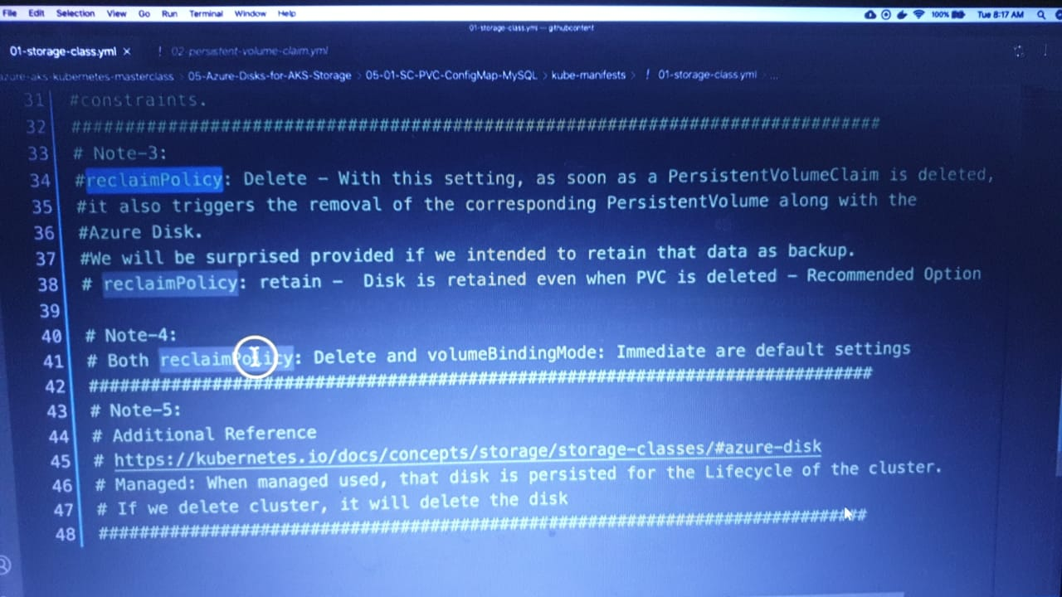

Step-02: Create following Kubernetes manifests

Create Storage Class manifest

https://kubernetes.io/docs/concepts/storage/storage-classes/#volume-binding-mode

https://kubernetes.io/docs/concepts/storage/storage-classes/#azure-disk

Create Persistent Volume Claims manifest

Create Persistent Volume  
Claim Manifest, Deploy SC, PVC and Test

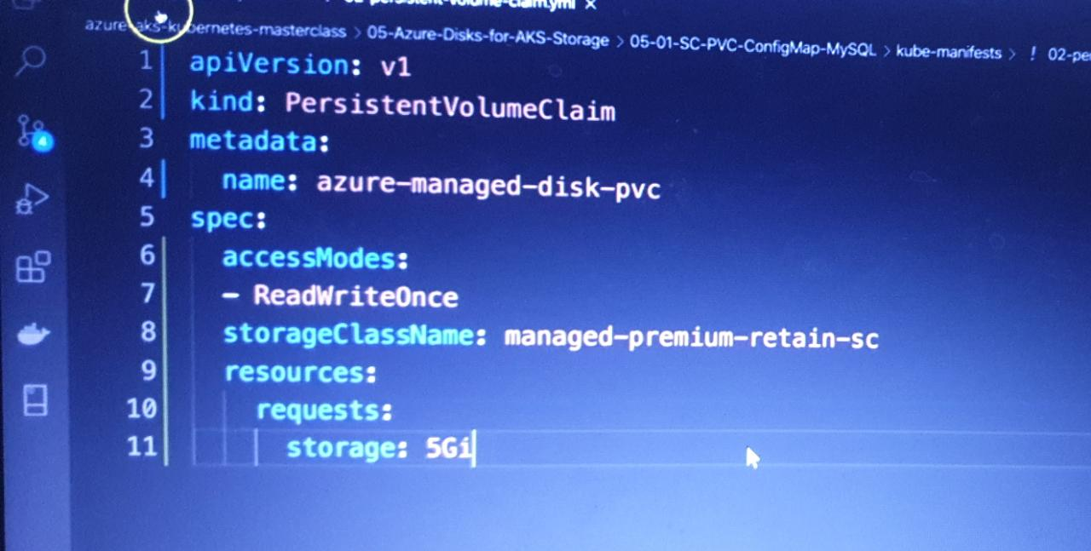

# Create Storage Class & PVC

kubectl apply -f kube-manifests/01-storage-class.yml

kubectl apply -f kube-manifests/02-persistent-volume-claim.yml

# List Storage Classes

kubectl get sc

# List PVC for persistent volume class

kubectl get pvc

# List PV

kubectl get pv

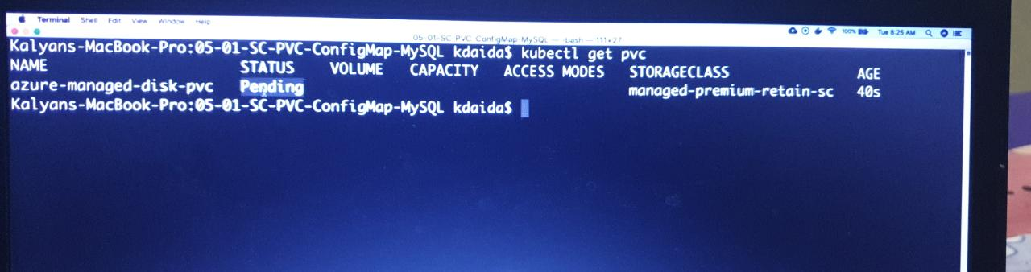

status is pending and once our db is deployed it will change the status

and we mentioned wait for first customer

**Create ConfigMap manifest**

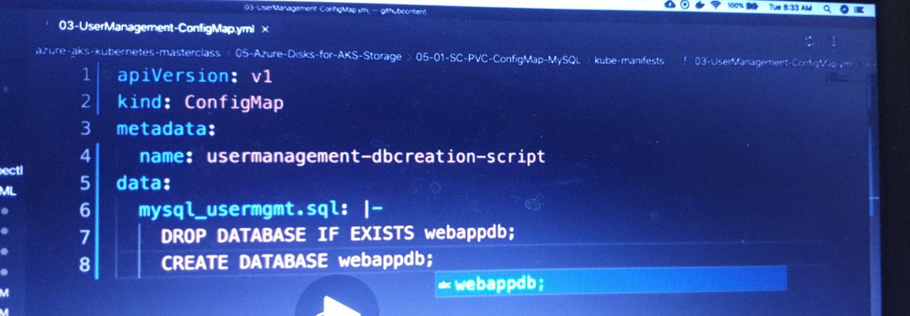

We are going to create a usermgmt database schema during the mysql pod creation time which we will leverage when we deploy User Management Microservice.

**Create MySQL Deployment manifest**

Environment Variables

Volumes

Volume Mounts

/docker-entrypoint-initdb.d will initialize the database

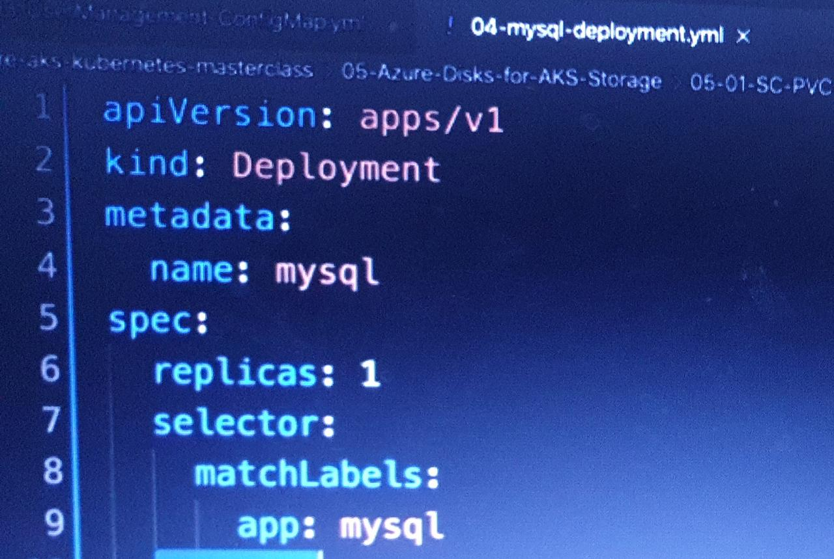

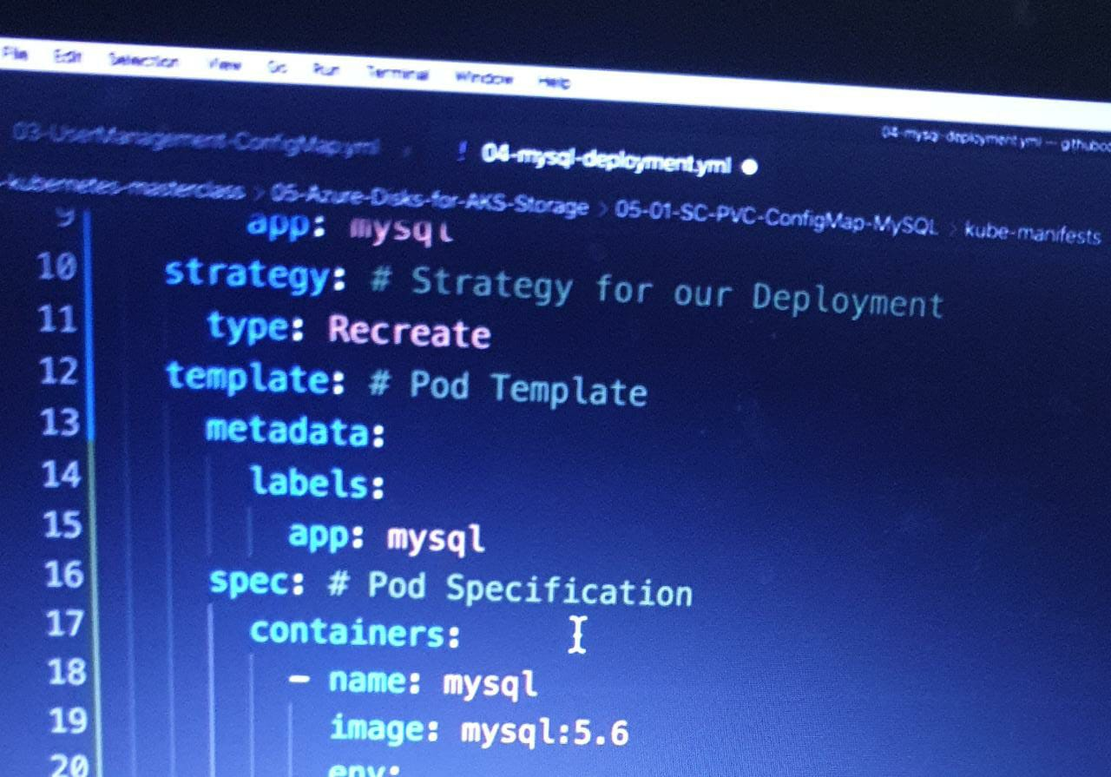

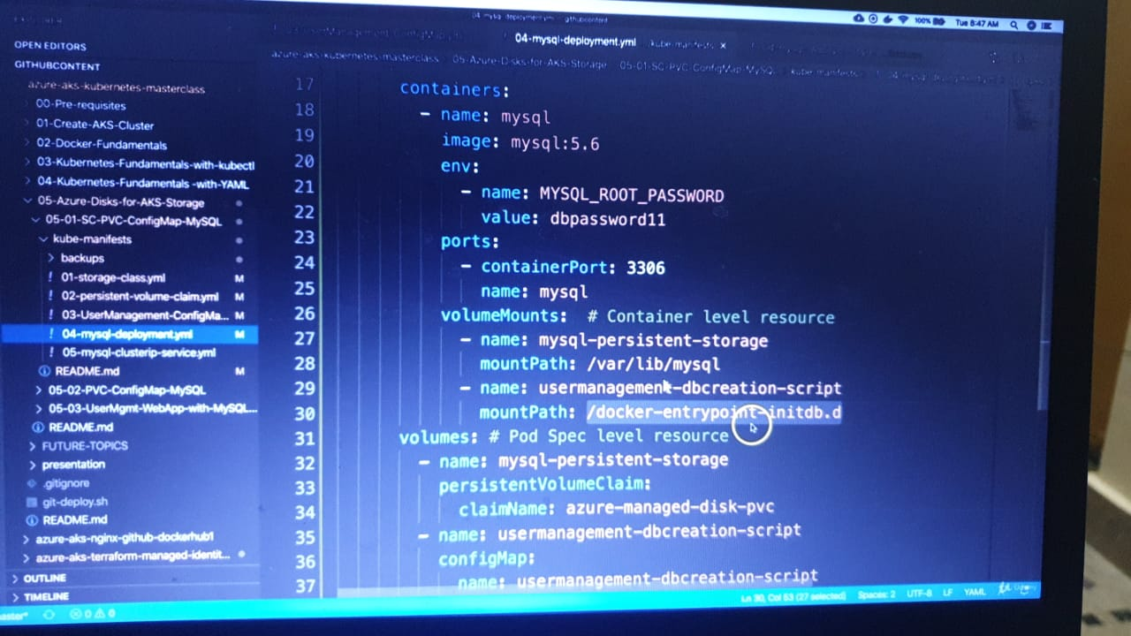

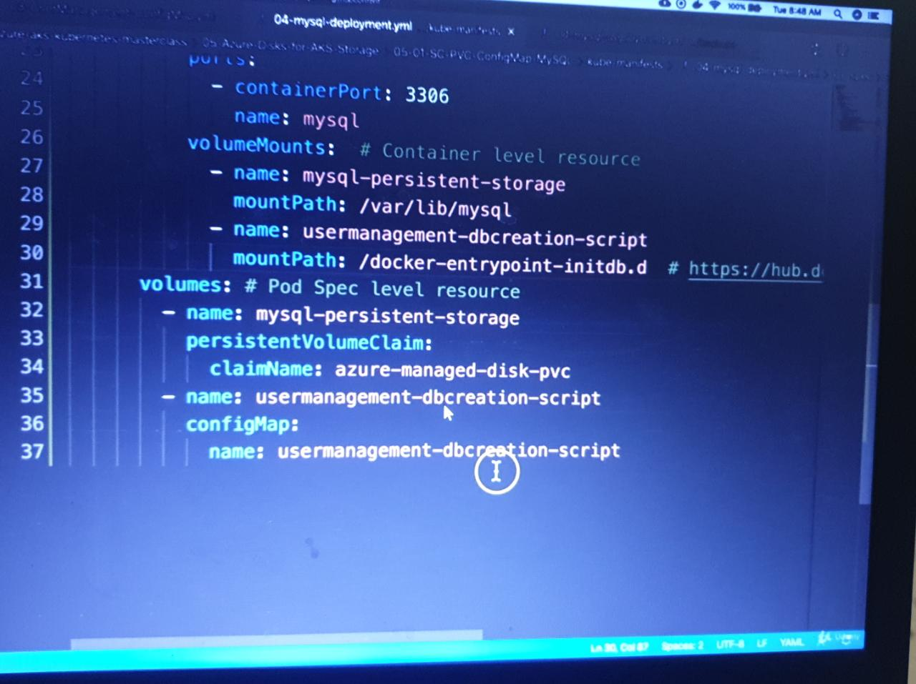

Create MySQL ClusterIP Service manifest

At any point of time we are going to have only one mysql pod in this design so ClusterIP: None will use the Pod IP Address instead of creating or allocating a separate IP for MySQL Cluster IP service.

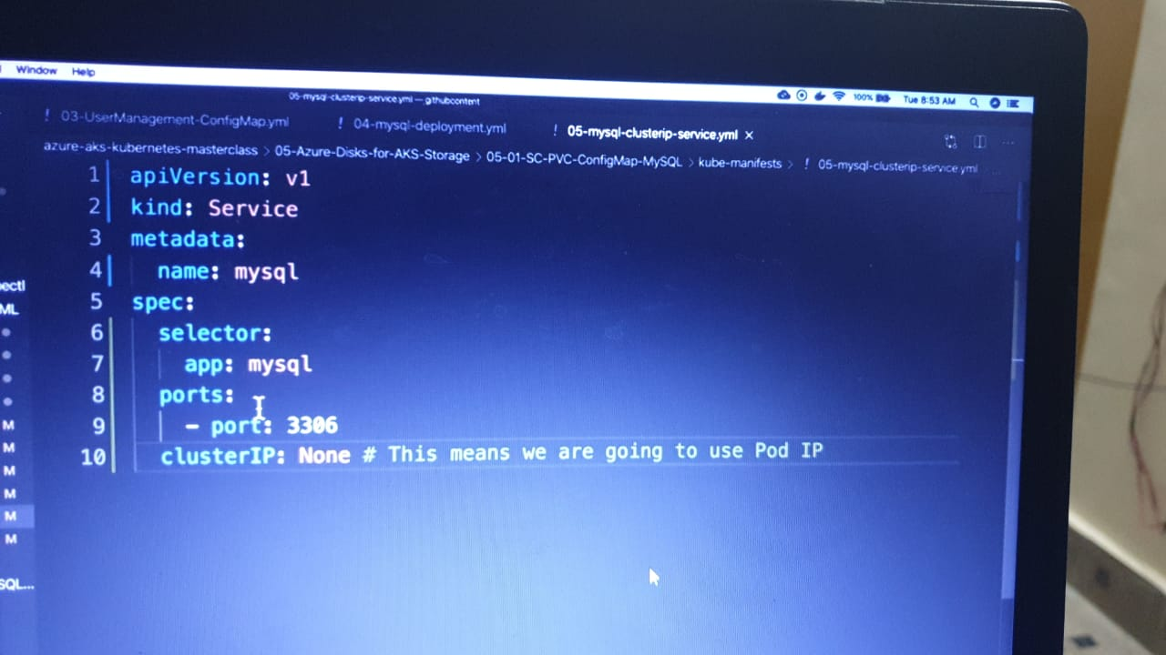

## Create MySQL Database with all above manifests

# Create MySQL Database

kubectl apply -f kube-manifests/

# List Storage Classes

kubectl get sc

# List PVC

kubectl get pvc

List PV

kubectl get pv

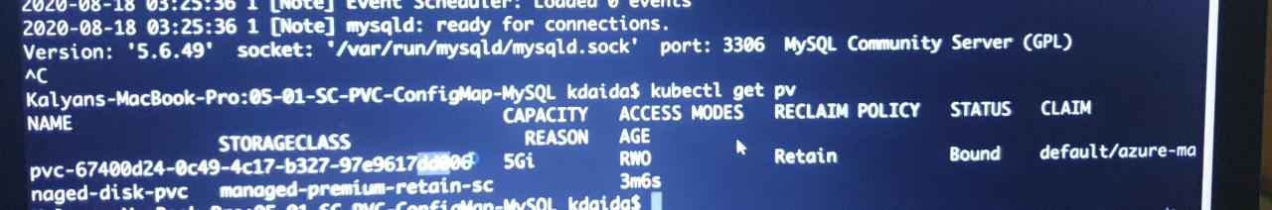

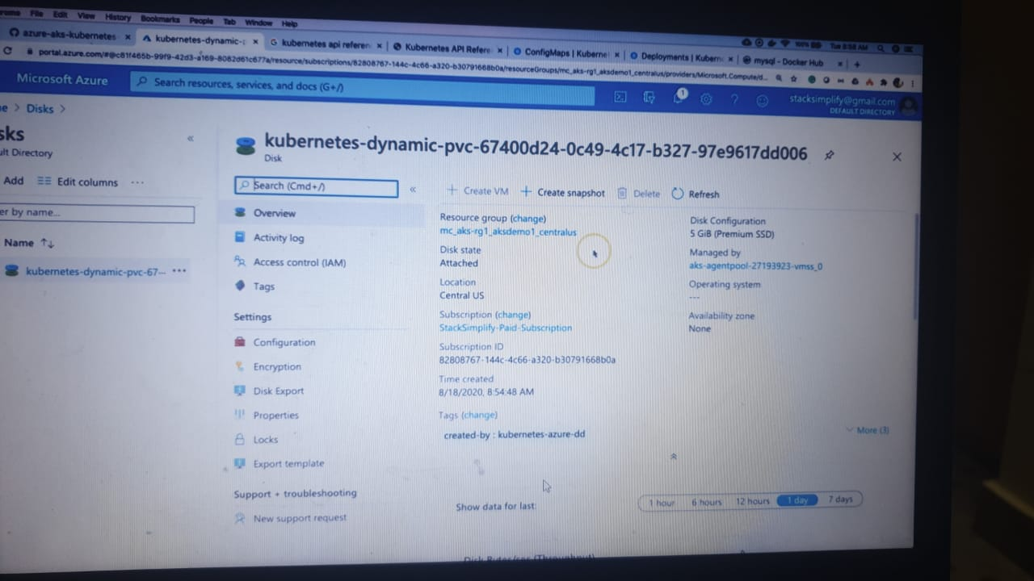

# List pods

kubectl get pods

kubectl describe podname

kubectl logs -f podname

# List pods based on label name

kubectl get pods -l app=mysql

Connect to MySQL Database

# Connect to MYSQL Database

kubectl run -it --rm --image=mysql:5.6 --restart=Never mysql-client -- mysql -h mysql -pdbpassword11

# Verify usermgmt schema got created which we provided in ConfigMap

mysql> show schemas;

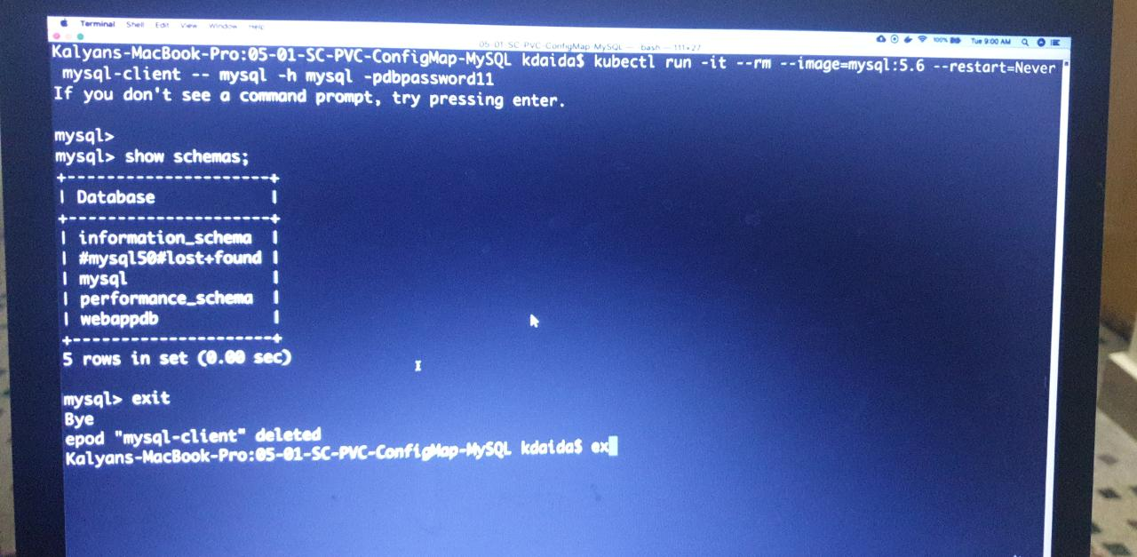

Step-05: Clean-Up

# Delete All

kubectl delete -f kube-manifests/

Step-06: Delete PV exclusively - It exists due to retain policy

# List PV

kubect get pv

# Delete PV exclusively

kubectl get pv

kubectl delete pv <PV-NAME>

# Delete Azure Disks

Go to All Services -> Disks -> Select and Delete the Disk

Step-07: References & Storage Best Practices

We need to discuss references exclusively here.

https://docs.microsoft.com/en-us/azure/aks/concepts-storage

https://docs.microsoft.com/en-us/azure/aks/operator-best-practices-storage

https://docs.microsoft.com/en-us/azure/aks/azure-disks-dynamic-pv

https://kubernetes.io/docs/concepts/storage/persistent-volumes/

https://kubernetes.io/docs/concepts/storage/storage-classes/#azure-disk

<https://kubernetes.io/docs/reference/generated/kubernetes-api/v1.18/#storageclass-v1-storage-k8s-io>

Use AKS provisioned Storage  
Class instead of Custom Storage Class

**Use AKS Provisioned Azure Disks**

* Copy all templates from previous section
* Remove Storage Class Manifest
* **Question-1:** Why do we need to remove storage class Manifests?
* Azure AKS provisions two types of storage classes well in advance during the cluster creation process
  + managed-premium
  + default-
* We can leverage Azure AKS provisioned disk storage classes instead of what we created manually.
* **Question-2:** If that is the case why did we use custom storate class in previous section?
* That is for us to learn the kind: StorageClass concept.

**Step-03: Review PVC Manifest 01-persistent-volume-claim.yml**

* Primarily we are going to focus on storageClassName: managed-premium which tells us that we are going to use Azure AKS provisioned Azure Disks storage class.

apiVersion: v1

kind: PersistentVolumeClaim

metadata:

name: azure-managed-disk-pvc

spec:

accessModes:

- ReadWriteOnce

storageClassName: managed-premium

resources:

requests:

storage: 5Gi

**Step-04: Deploy and Test**

# Create MySQL Database

kubectl apply -f kube-manifests/

# List Storage Classes

kubectl get sc

# List PVC

kubectl get pvc

# List PV

kubectl get pv

# List pods

kubectl get pods

**Step-05: Connect to MySQL Database**

# Connect to MYSQL Database

kubectl run -it --rm --image=mysql:5.6 --restart=Never mysql-client -- mysql -h mysql -pdbpassword11

# Verify usermgmt schema got created which we provided in ConfigMap

mysql> show schemas;

**Step-06: Clean-Up**

# Delete all manifests

kubectl delete -f kube-manifests/

Deploy UserManagement Web Application with MySQL Database

* We are going to deploy a **User Management Web Application** which will connect to MySQL Database schema **webappdb** during startup.
* Then we can test the following APIs
  + Create Users
  + List Users
  + Delete User

| **Kubernetes Concepts** | **YAML File** |
| --- | --- |
| Deployment | 05-UserMgmtWebApp-Deployment.yml |
| Environment Variables | 05-UserMgmtWebApp-Deployment.yml |
| Init Containers | 05-UserMgmtWebApp-Deployment.yml |
| Load Balancer Service | 06-UserMgmtWebApp-Service.yml |

**Create following Kubernetes manifests**

**Create User Management Web Application k8s Deployment manifest**

* **Environment Variables**

| **Key Name** | **Value** |
| --- | --- |
| DB_HOSTNAME | mysql |
| DB_PORT | 3306 |
| DB_NAME | webappdb |
| DB_USERNAME | root |
| DB_PASSWORD | dbpassword11 |

* **Problem Observation:**
  + If we deploy all manifests at a time, by the time mysql is ready our User Management Web Application pod will be throwing error due to unavailability of Database.
  + To avoid such situations, we can apply initContainers concept to our User management Web Application Deployment manifest.
  + We will see that in our next section but for now lets continue to test the application

**Create User Management Web Application Load Balancer Service manifest**

* LoadBalancer Service
* **Step-03: Create UserManagement Web Application Deployment & Service**
* # Create Deployment & LoadBalancer Service

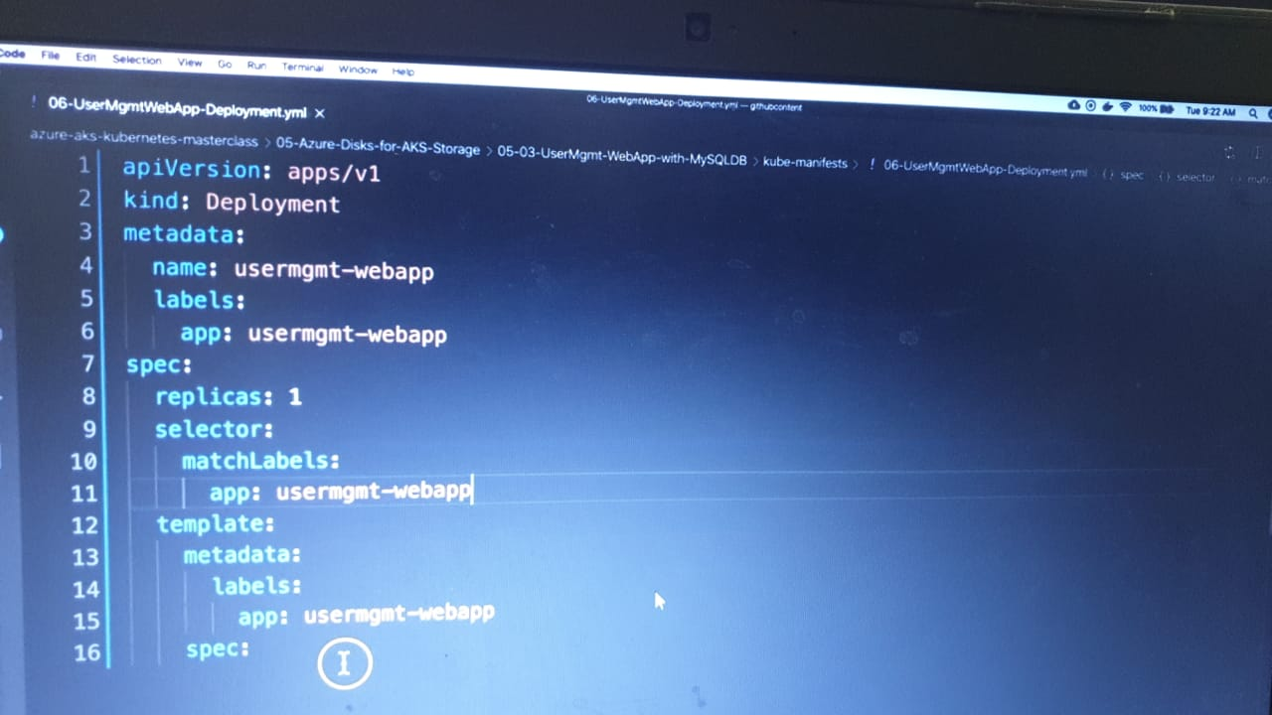

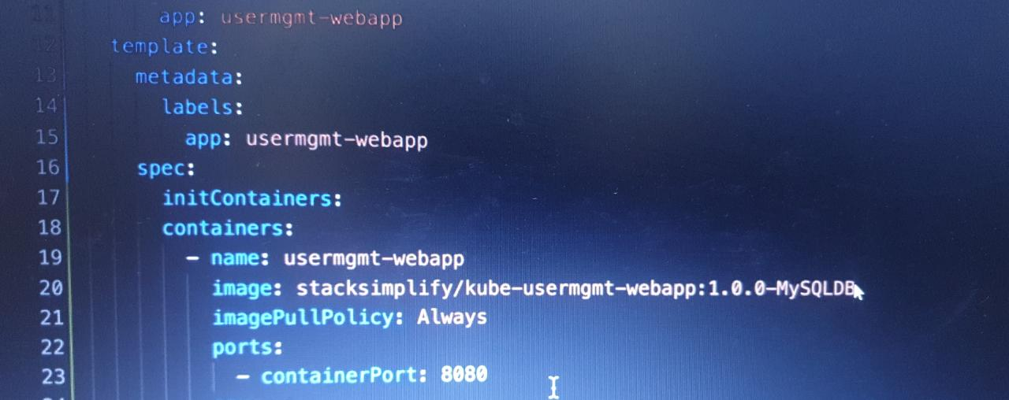

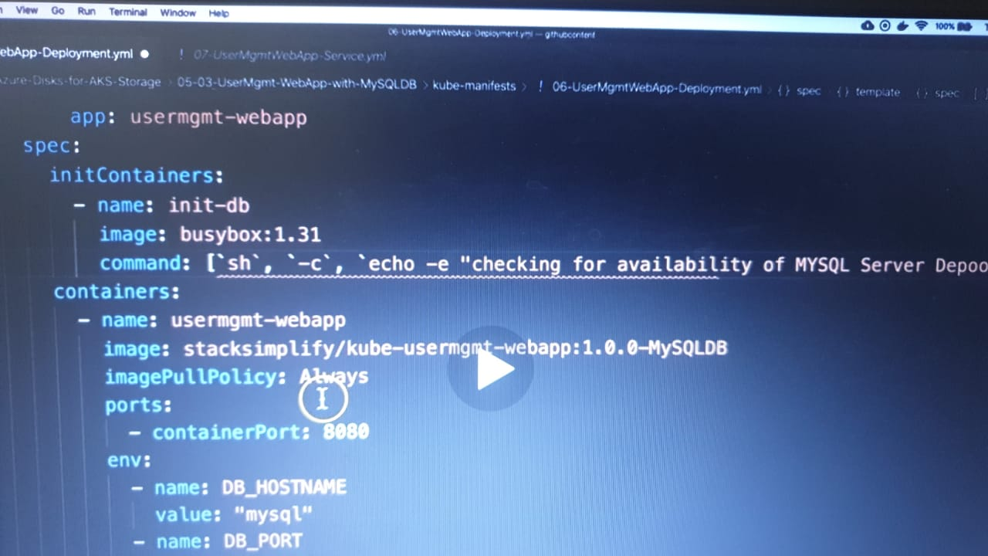

Init containers If my sql container is UP then only it will go the starting of web application

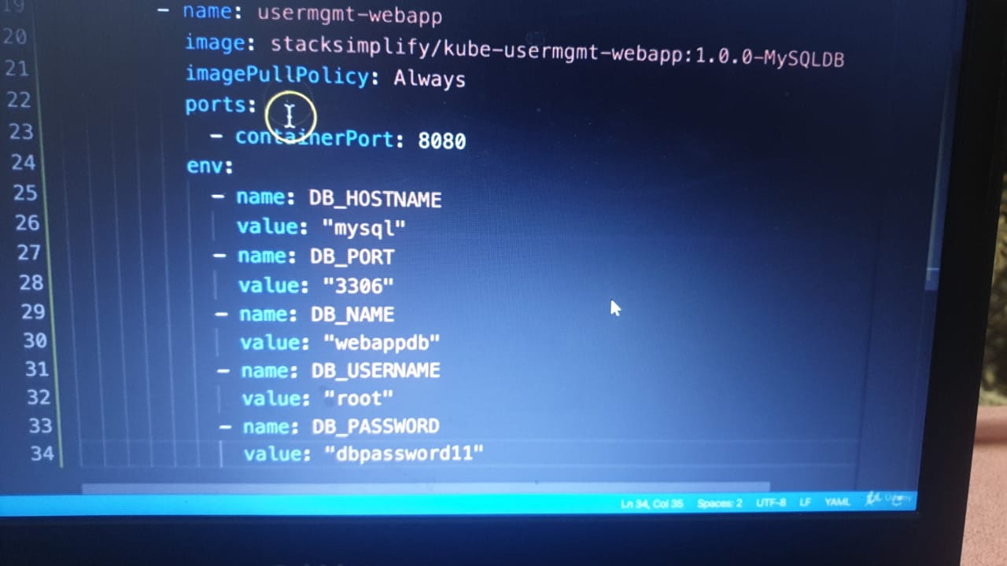

And for service

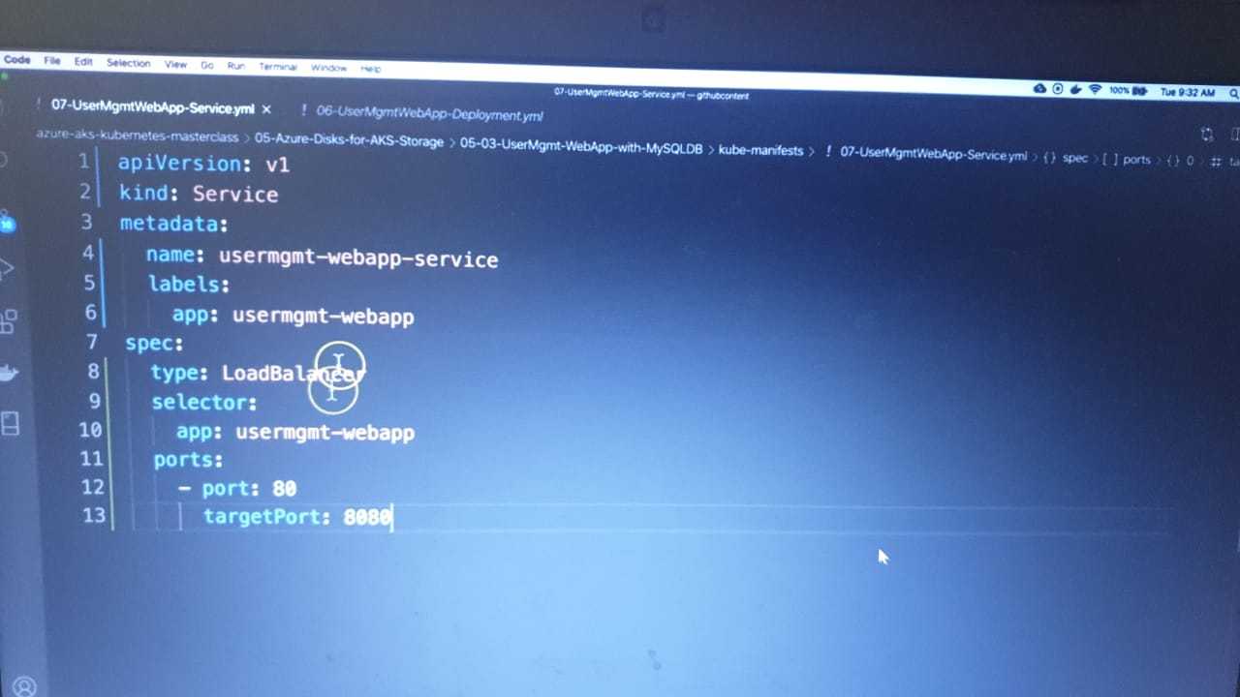

kubectl apply -f kube-manifests/

# List Pods

kubectl get pods

# Verify logs of Usermgmt Web Application Pod

kubectl logs -f <pod-name>

# If we have only 1 pod, below commnad works well for getting the logs

kubectl logs -f $(kubectl get po | egrep -o 'usermgmt-webapp-[A-Za-z0-9-]+')

# Verify sc, pvc, pv

kubectl get sc,pvc,pv

* **Access Application**

# List Services

kubectl get svc

# Access Application

http://<External-IP-from-get-service-output>

Username: admin101

Password: password101

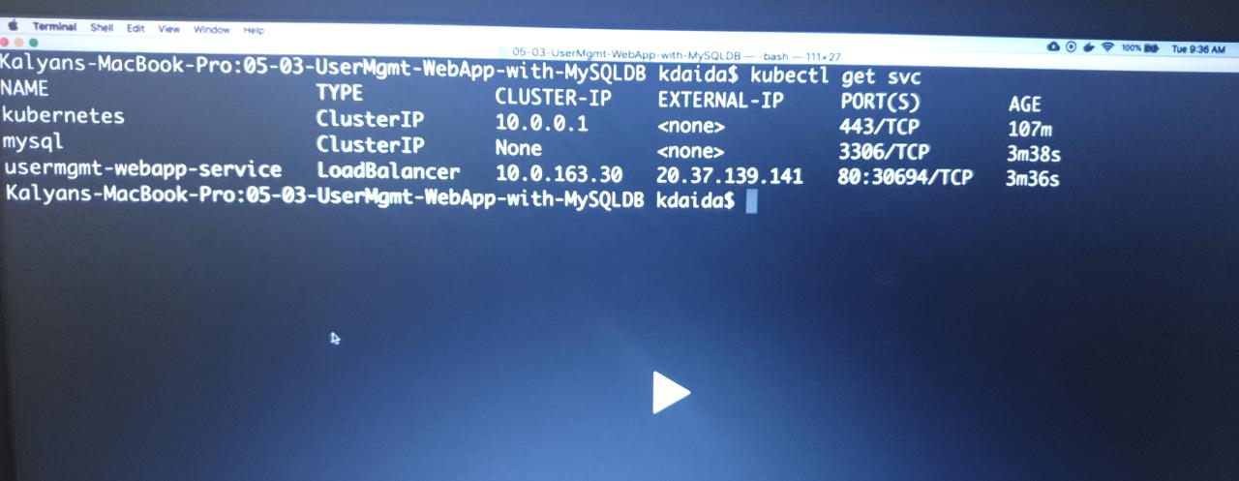

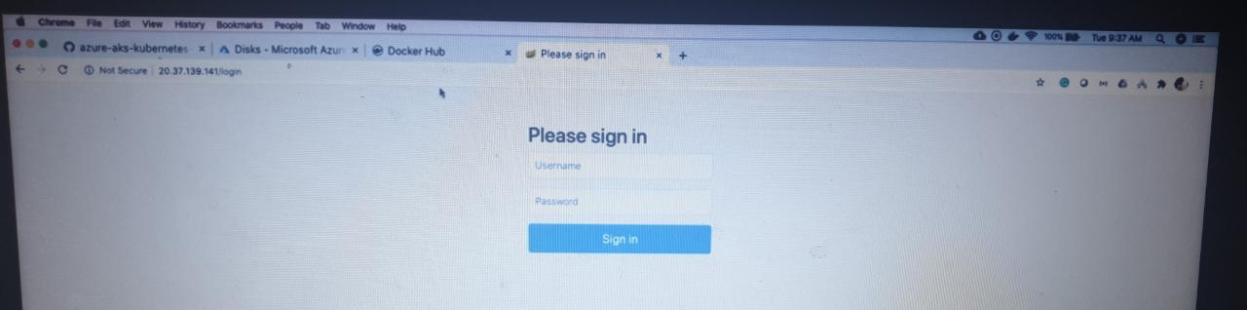

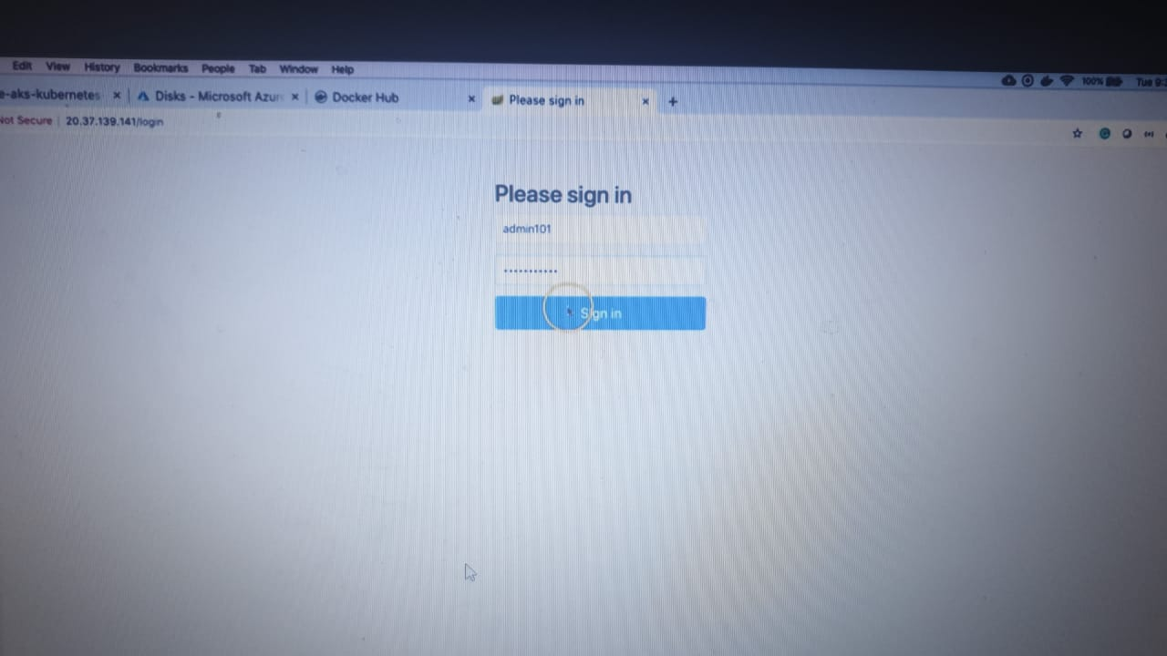

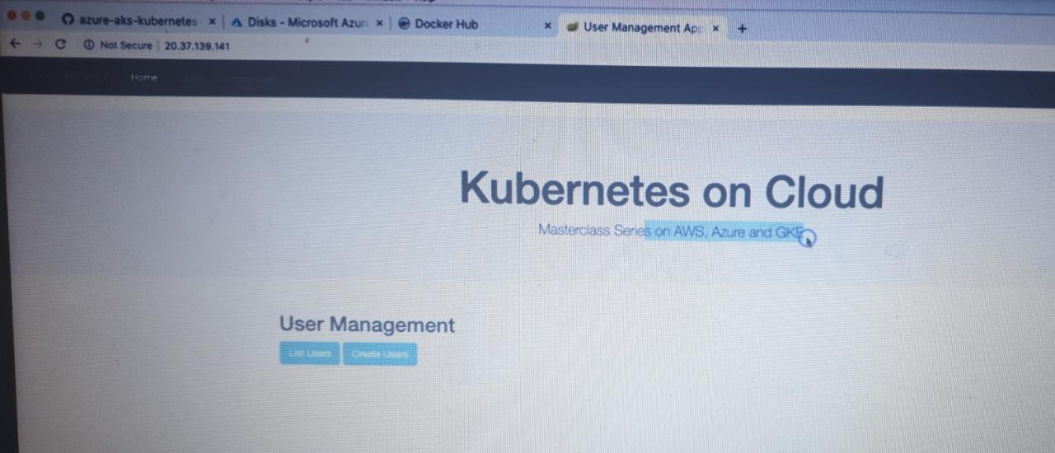

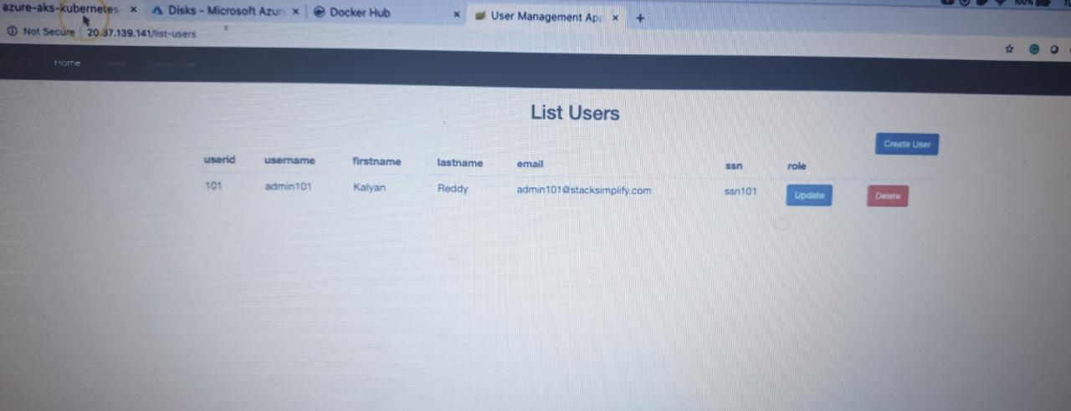

**Step-04: Test User Management Web Application using Browser**

* Usecase-1: Login, List Users and Logout
  + Username: admin101
  + Password: password101
* Usecase-2: Login,> Create New User and Logout and login with new user
  + Username: admin101
  + Password: password101
  + Create New User
    - User Details: admin102, password102, fname102, lname102, [admin102@gmail.com](mailto:admin102@gmail.com), ssn102
  + Login with newly user and list users
    - Username: admin102
    - Password: password102

**Step-05: Verify Users in MySQL Database**

# Connect to MYSQL Database

kubectl run -it --rm --image=mysql:5.6 --restart=Never mysql-client -- mysql -h mysql -pdbpassword11

# Verify usermgmt schema got created which we provided in ConfigMap

mysql> show schemas;

mysql> use usermgmt;

mysql> show tables;

mysql> select * from user;

**Step-06: Clean-Up**

* Delete all k8s objects created as part of this section

# Delete All

kubectl delete -f kube-manifests/

# List Pods

kubectl get pods

# Verify sc, pvc, pv

kubectl get sc,pvc,pv

# Delete PV Exclusively

kubectl get pv

kubectl delete pv <PV-NAME>

# Delete Azure Disks

Go to All Services -> Disks -> Select and Delete the Disk